CST 229 – Lecture 2
Wilsonville, Fall 2017
Ch 5, 7: DFA, NFA, RE = NFA = DFA

Finite Automata (FA)
For every regular language, there is a regular expression that describes it.
For every regular language, there is a machine that recognizes all of the sentences in the language. This machine is known as the finite state machine, or finite automata

A finite automata act like a black box. It takes sentences of the language as input and outputs either Yes or No indicating whether or not the sentence is in the language or not

Finite Automata (FA) have the following components:
Q – A finite collection of states
∑ − Α finite alphabet of input letters
δ − Α function which determines next state based on current state and input letter

Two types of states are special:
q₀ = Initial state (q₀∈ Q)
F = Final states – (YES states, can be more than one)

When the FA operates, it will accept any sequence of letters which ends in a final states

The set of all accepted sequences are sentences in the language of the machine

There are 3 different ways to represent a FA:
A FA to accept a sequence of a's, defining language L(M) = {a, aa, aaa, ....}

- Graphical Representation:
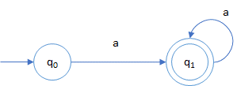

- Table Representation:
state | a | Accept?
q₀ | q₁
q₁ | q₁ | yes

- Math Model Representation:
Q = {q0, q1}
∑ = {a}
δ: δ (q₀, a) = q₁
δ (q₁, a) = q₁
Start state = q₀
Final state F = {q₁}

A character string over ∑ is accepted by a Finite Automata, named M, if, when the last character has been read, M is one of the accepting states.

Nondeterministic Finite Automata (NFA)
NFAs have several unexpected characteristics, but are very useful

- The automaton can change state without reading an input character (λ-transitions)
- May include transitions to more than one state for the same input character or λ

The behavior of these FAs from moment to moment are unpredictable!
That’s why they’re called non-deterministic

A NFA accepts an input string x, if and only if there is some path in the transition graph from the start state to some accepting state, such that the edge labels along this path spell out x

If there is a path for input string x that does not end in an accepting state, that is irrelevant, as long as there is at least one path that does end in an accepting state

While transitions between individual states are unpredictable, they do behave predictably as a whole (more on this later)

Example NFA:

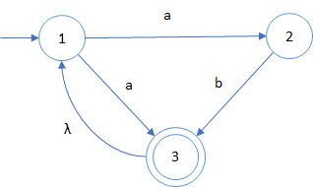

How will this machine behave when it tries to accept string “abaab”?

This machine looks like the following in table form:

State | a | b | λ | Accept?
1 | {2, 3}
2 |  | 3
3 |  |  | 1 | yes

Note that “next state” for transitions are actually sets.

Why would we use NFAs, given their unpredictability?
NFAs are very flexible and simple to use when specifying languages (more later…)

Deterministic (DFA)
DFAs are a special case of NFAs, where…
- There are no λ-transitions
- For each state s and input symbol a, there is at most one next state

DFA’s are very useful because we can easily code them up!
How can we get the power of an NFA, but the codability of a DFA?

NFA to DFA conversion
Turns out we can convert any NFA into an equivalent DFA!

For any NFA, named M, we can construct an equivalent DFA, named M’
M’ simulates the operation of M by having one state for every subset of M-states
The set of strings accepted by a NFA is the set that is accepted by the equivalent DFA

Subset construction algorithm for converting NFAs to DFAs:
Each DFA state corresponds to a set of NFA states
The trick is to create new DFA states only as we need them

Subset construction (w/o λ-transitions):
- Begin with the NFA’s start state as it’s own sub-set and the first DFA state
- For each DFA state…
  - For each input symbol ‘a’…
    - Find N({s₁, s₂,…s_{k}}, a) = T, where T is a set of destination states
    - If T is not in the list of DFA states, add it to the table.
- Identify DFA accepting states as any sub-set that includes an NFA accepting state

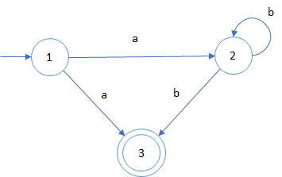
Example NFA:

State | a | b | Accept?
1 | {2, 3}
2 |  | {2, 3}
3 |  |  | yes

How do we convert this to a DFA?

Use Sub-set construction…
- Create DFA start state A = {1}, because state 1 is the NFA’s start state

DFA State | a | b | Accept?
A {1}

- Find the next states for DFA state A, input ’a’, leads to next states {2,3}, which is not in the DFA state list yet, so create B = {2,3}

DFA State | a | b | Accept?
A {1} | B
B {2,3}

- There are no transitions from A on input ‘b’, so leave that blank
- Now start with DFA state B and input ‘a’, neither NFA state 2, nor state 3 have transitions for input ‘a’, so leave that blank too.
- Continue with DFA state B and input ‘b’, and we see that NFA state 2, can transition to itself and to NFA state 3, but NFA state 3 has no transitions, so the possible destinations are {2, 3}, which is already in our list as DFA state B

DFA State | a | b | Accept?
A {1} | B
B {2, 3} |  | B

- We have no more DFA state / input symbol combinations, so we’re done identifying state
- Which DFA states are accepting states? Any sub-set that includes NFA state 3

DFA State | a | b | Accept?
A {1} | B
B {2, 3} |  | B | yes

And this DFA looks like…

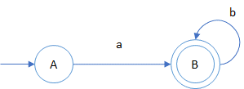

To tackle λ-transitions, we need the following operation:
λ-closure = Set of NFA states reachable by λ –transitions alone

Subset construction (w/ λ transitions)
- Begin with the λ-closure of the NFA’s start state as the first DFA state
- For each DFA state…
  - For each input symbol ‘a’…
    - Find the λ-closure N({s₁, s₂,…s_{k}}, a) = T, where T is a set of destination states, including those reachable by λ-transitions
    - If T is not in the list of DFA states, add it to the table.
- Identify DFA accepting states as any sub-set that includes an NFA accepting state
Example NFA, including λ-transitions:

State | a | b | λ | Accept?
1 | {2, 3}
2 |  | 3
3 |  |  | 1 | yes

Use Sub-set construction…
- Create DFA start state A = {1}, because state 1 is the NFA’s start state. The λ-closure of A does not bring in any new states, because there are now λ-transitions away from state 1.

DFA State | a | b | Accept?
A {1}

- Find the next states for DFA state A, input ’a’, leads to next states {2,3}. Now we take the λ-closure of {2, 3} and find that we must add state 1, because of the λ-transition from 3 back to 1. This leads to sub-set {1,2,3}, which is not in the DFA state list yet, so create B = {1, 2,3}

DFA State | a | b | Accept?
A {1} | B
B {1,2,3}

- There are no transitions from A on input ‘b’, so leave that blank
- Next we need the transitions from state B on input ‘a’, which leads to {2,3}, and again the λ-closure of {2, 3} includes state 1, so we’re back to {1,2,3} = B

DFA State | a | b | Accept?
A {1} | B
B {1,2,3} | B

- And for state B, on input ‘b’, we find that only state 2 includes a transition for ‘b’, giving sub-set {3}, then the λ-closure of {3} includes state 1, so we’re at {1,3}, which is not in our list yet, so we’ll add it and label it C

DFA State | a | b | Accept?
A {1} | B
B {1,2,3} | B | C
C {1,3}

- For state C on input ‘a’, we get sub-set {1,2,3}, including λ-closure

DFA State | a | b | Accept?
A {1} | B
B {1,2,3} | B | C
C {1,3} | B

- For state C on input ‘b’, we find that neither 1, nor 3 has a transition for ‘b’
- Finally, we see that both B and C include final NFA state 3, so…

DFA State | a | b | Accept?
A {1} | B
B {1,2,3} | B | C | yes
C {1,3} | B |  | yes

And this looks like…

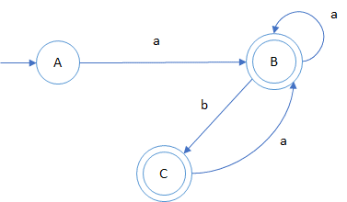

Which is equivalent to the original NFA!

RE to NFA conversion
Ultimately, we would like to convert regular expressions to DFAs, so we can quickly code up acceptors for regular languages

However, it’s tough to come up with a DFA for any RE
It is relatively easy to convert REs to NFAs… using some tricks:

- Begin with a start state and an accepting state with a place holder in the middle for the RE
- Replace a place holder with more states and possibly place holders by decomposing the RE into more primitive REs.
- Repeat step 2 until there are no more placeholders

We can use λ-transitions to model kleene-closure *, positive-closure + and OR |

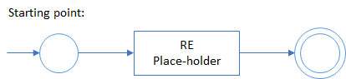

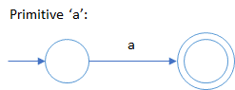

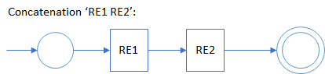

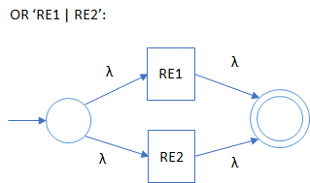

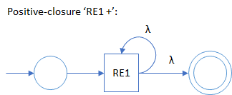

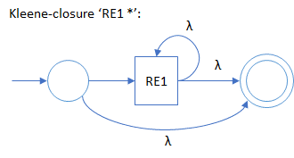

Try an example: (a|b)*
Convert this to an NFA and then to a DFA

